How to re-create the track ‘Spry’ by dise on Ableton Live

**ABLETON LIVE 10 INTRO MINIUMUM REQUIRED, ABLETON LIVE 10 STANDARD RECOMMENDED; ABLETON LIVE 10 SUITE IS USED IN THE SCREENSHOTS**

Before I start off, I’d like to say that I am completely self-taught on Ableton. When I first encountered the UI I started experimenting with the drum racks and a bunch of other stuff and I found out “Ah, this does that… that does this…”

If I was asked to teach anyone how to use Ableton for the first time ever, I probably wouldn’t know what to say. I barely even know the actual names of functions on Ableton. I just know how they work.

1. Notes

All the mixes of ‘Spry,’ which is the ‘Pleasure Mix’ and the ‘Rave Mix’ are created in this one Ableton project, though you may want to make multiples, because they have different BPMs. The BPM of the ‘Pleasure Mix’ is 135 and the BPM of the ‘Rave Mix’ is 170.

1. What you need

First off, you’re going to need a sample library called ‘Essential Clubsounds Vol. 1’ by Vengeance. This sample library usually comes in WAV format. Also, you’re going to need the DAW software LMMS. We won’t be using LMMS, but we need the sample ‘kick_hardcore01.ogg’ that comes with the software. LMMS comes with a whole bunch of useful samples. The only con with them is that they’re low quality; so you’re probably better off using an actual sample library. I’d still recommend getting LMMS though, because a.) Its open-source meaning that you can change it around if you know what you’re doing b.) It comes with good samples (despite the low quality) and c.) It’s good to experiment with. No other sample libraries are needed. Also, you’re going to need a MIDI file of ‘Back to Cali (Push Remix)’ by Mauro Picotto since this track samples it.

1. Channel 1 — tops loop

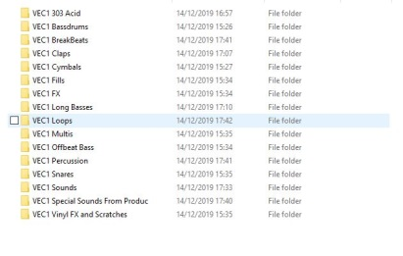Channel 1 is the tops loop. The tops loop is in channel 1 section 1, and channel 1 section 2. The WAV file is ‘Loops140 369.wav’ and can be found in the ‘Loops’ folder in the sample library.

1. Channel 2 — creating the Drum Rack

Channel 2 consists of a custom made drum rack. In Ableton, there are drum racks, which are basically virtual drum machines (such as 909 Core Kit and Cashon Kit). To create your own, follow the steps below.

1. 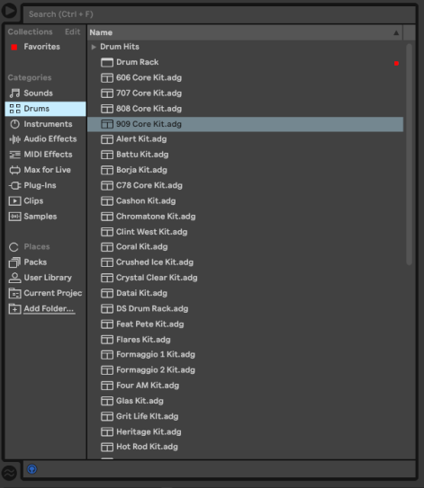On the browser to the left to your Ableton window, go to the **Drums** section.

On the top of the **Drums** section below **Drums Hits,** drag and drop **Drum Rack** to an empty space **(NOT AN EXISTING CHANNEL)** in the Session view.

1. On the bottom of the screen, select **Drum Rack.**

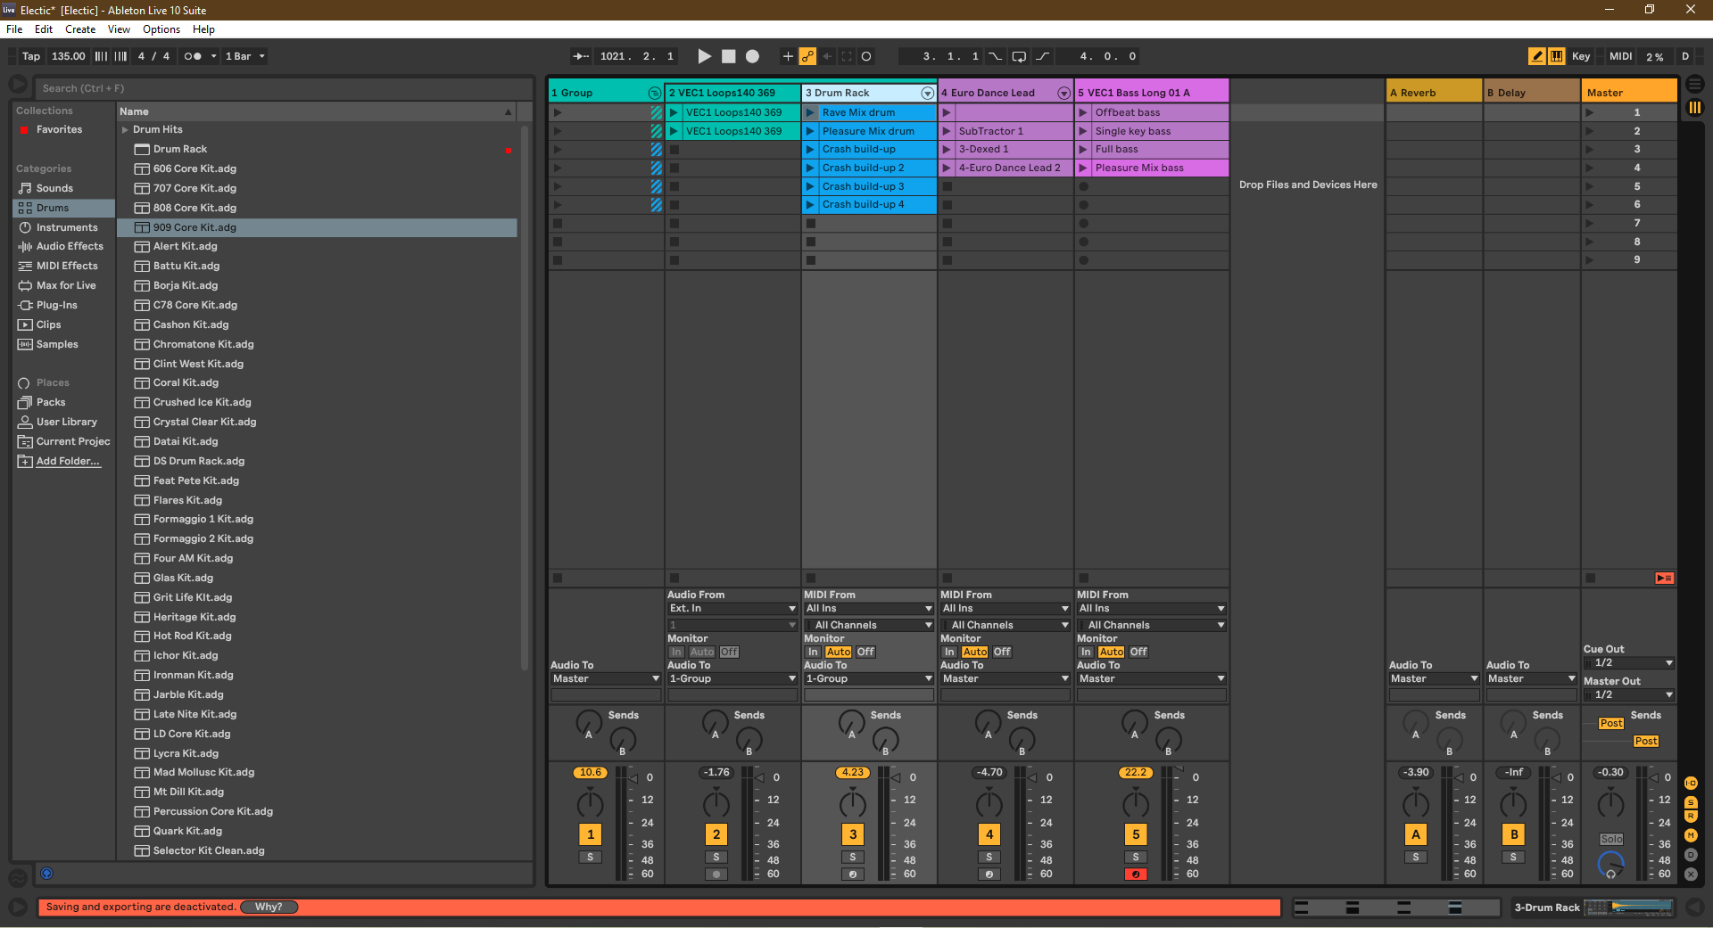

1. Now, you need to collect the required samples. You can find the LMMS samples by going to its install directory and using the search tool with the Windows Explorer/Mac Finder (you can do the same with Essential Clubsounds). They are:

* ‘kick_hardcore01.wav’ from LMMS
* ‘BD Clubby15.wav’ from Essential Clubsounds Vol. 1
* ‘BD ReverbFX 01.wav’ from Essential Clubsounds Vol. 1
* ‘Clap 001.wav’ from Essential Clubsounds Vol. 1

Now that you have the samples, put them into the **Drum Rack.** You can do this by dragging & dropping them into the sample space.

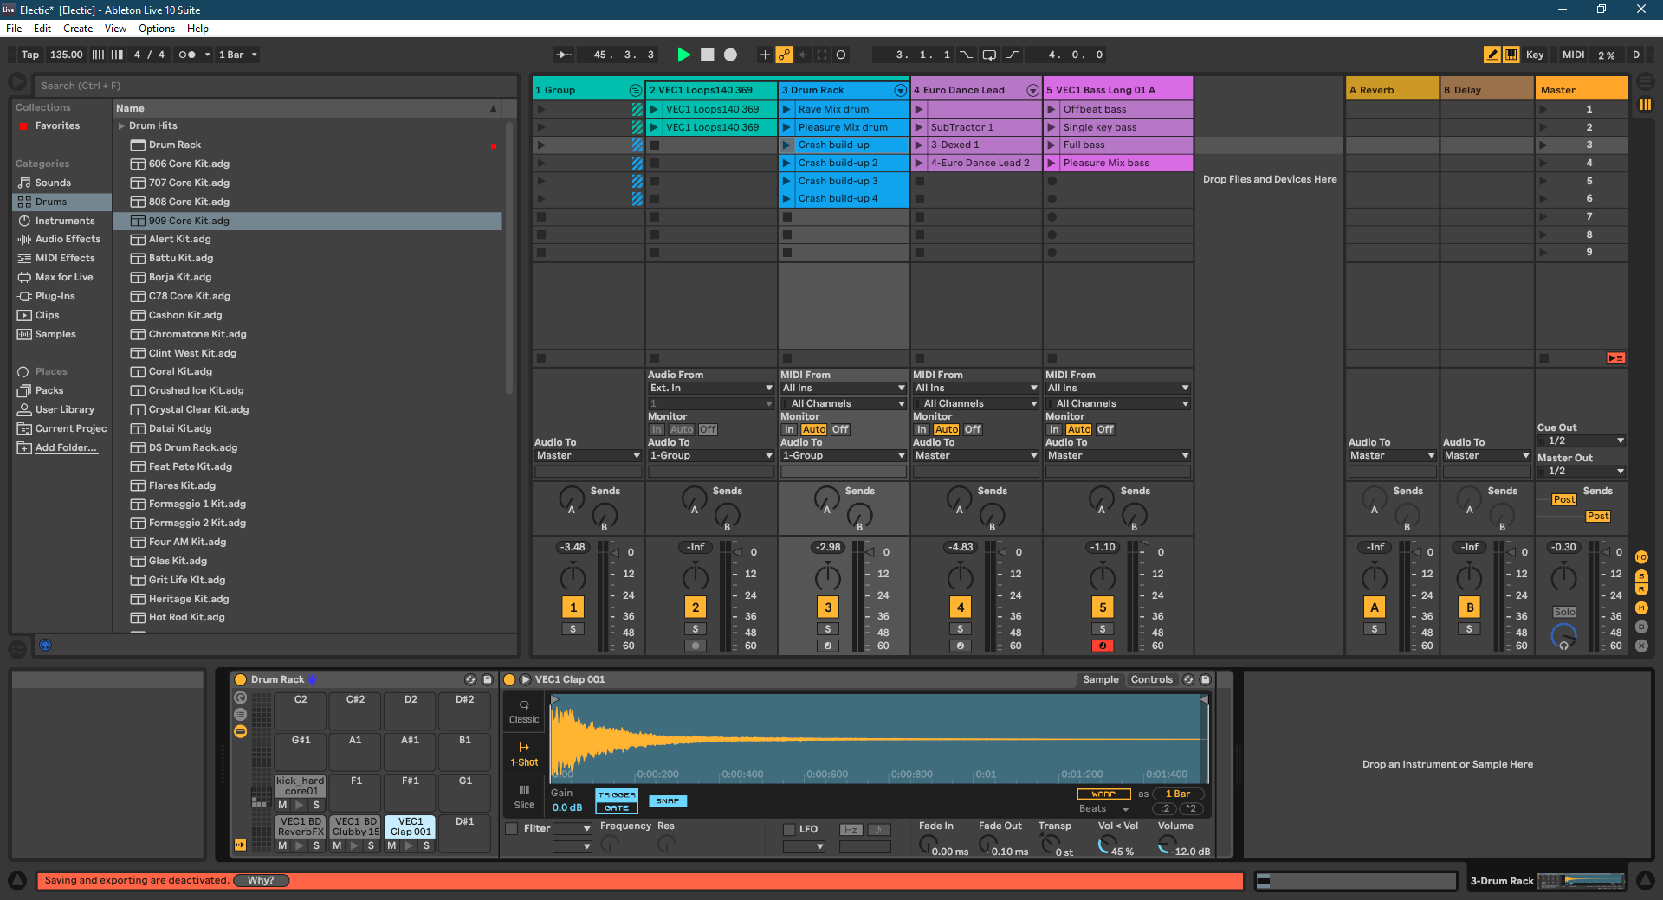

1. 2 Channel 2 — creating the patterns

As you can see in the screenshot above, there are six patterns in channel 2. To start off, we are going to create section 1’s pattern in channel 2. These patterns can be easily re-created using the screenshots below.

Section 1 — Rave Mix drum

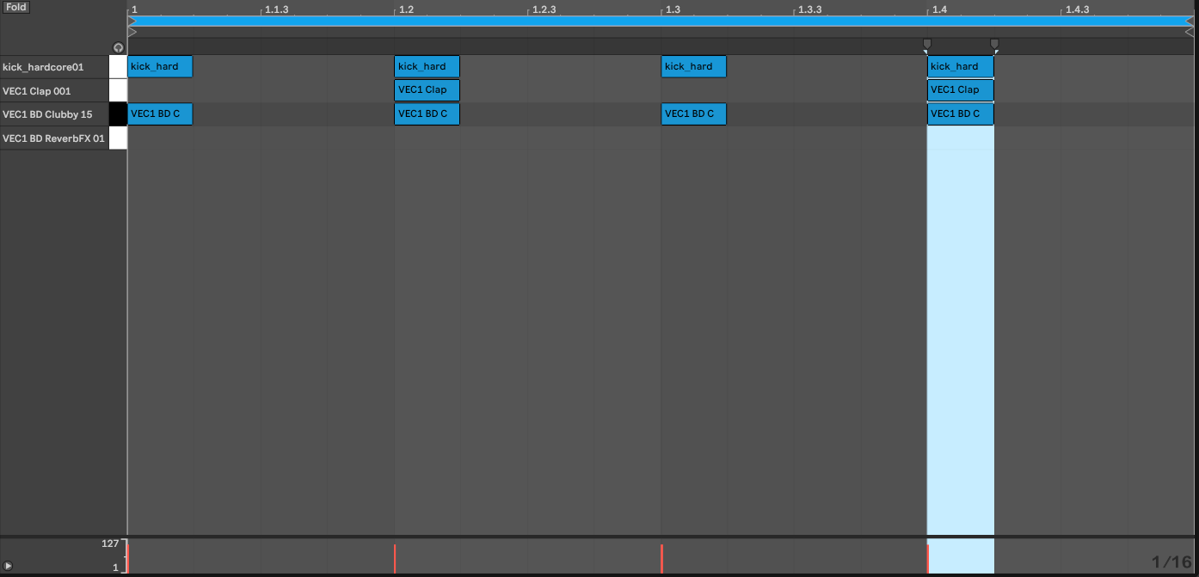

Section 2 — Pleasure Mix drum

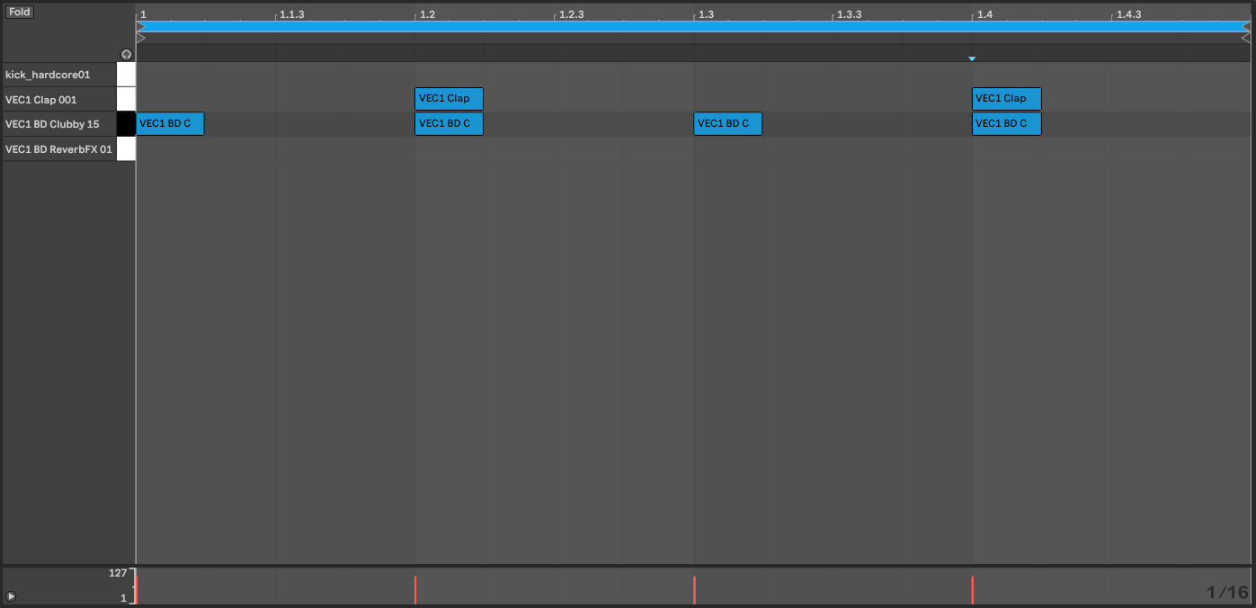

Section 3 — Crash build-up

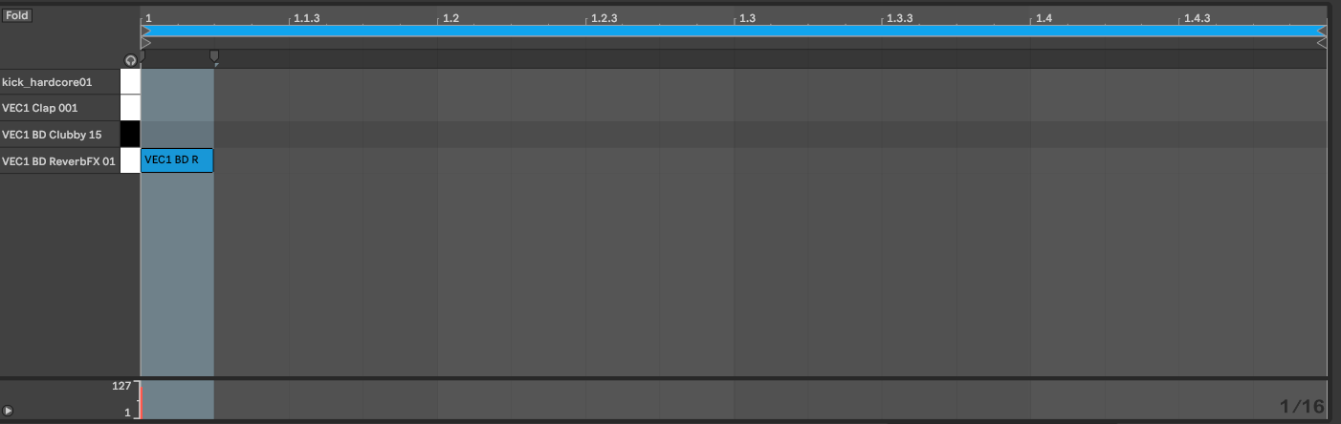

Section 4 — Crash build-up 2

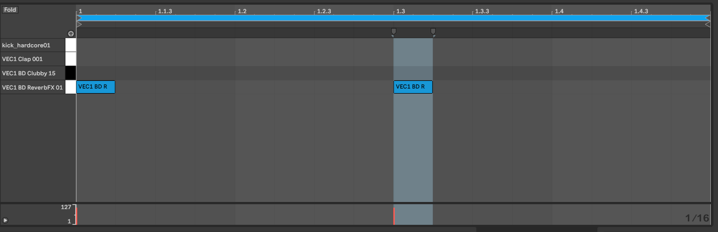

Section 5 — Crash build-up 3

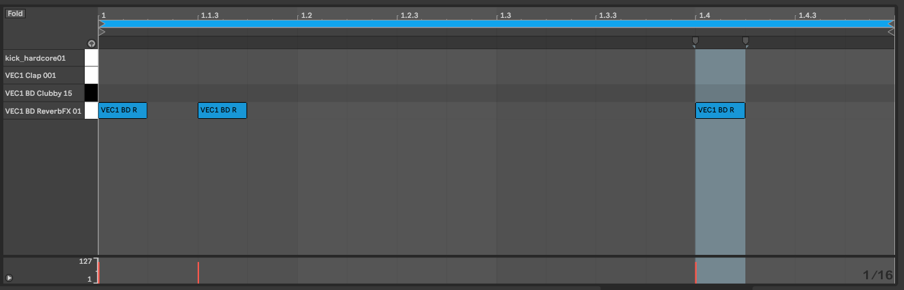

Section 6 — Crash build-up 4

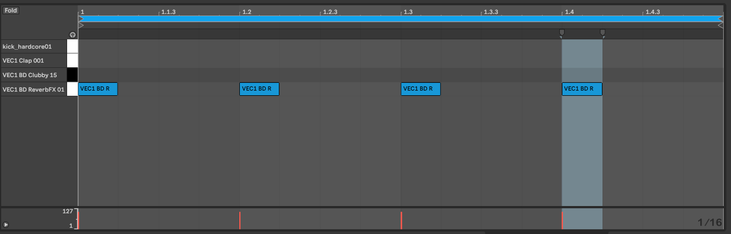

Once you’re done, hold Ctrl and click on channels 1 & 2, right click them and then group them.

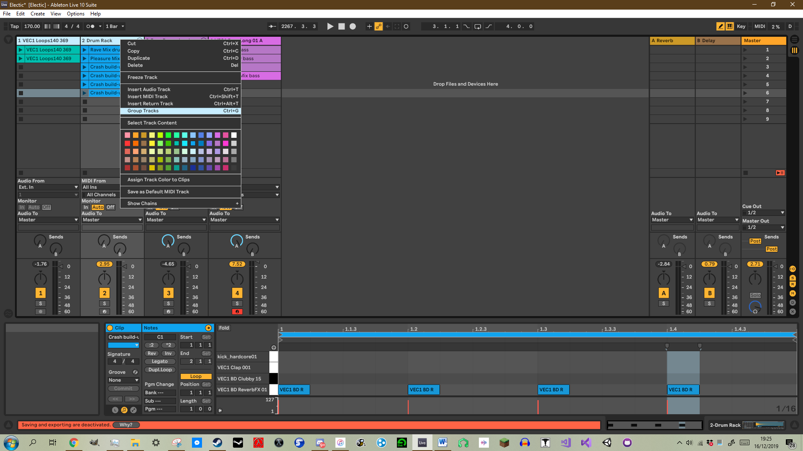

1. Channel 3 — Euro Dance Lead

Press Ctrl + Shift + C on your keyboard and it will create a new MIDI channel in Ableton. Then, to the right of your screen in the Explorer, go to the **Instruments** section, then go to **Instrument Rack, Synth Rhythmic,** and then drag & drop **Euro Dance Lead** into the new MIDI channel you just created. Now, we can create the patterns. There is no pattern in section 1, but there’re patterns in sections 2-4. Section 2 uses the ‘SubTractor 1’ channel from the MIDI file of ‘Back to Cali (Push Remix)’ by Mauro Picotto. The section 2 clip is cut to only play the first 4 steps/beats of the melody.

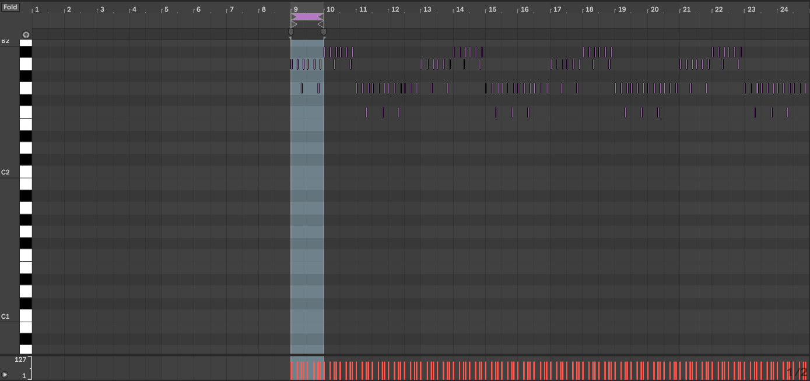

Section 4’s melody is also only 4 beats/steps long. It is C2 and then D2 over and over again.

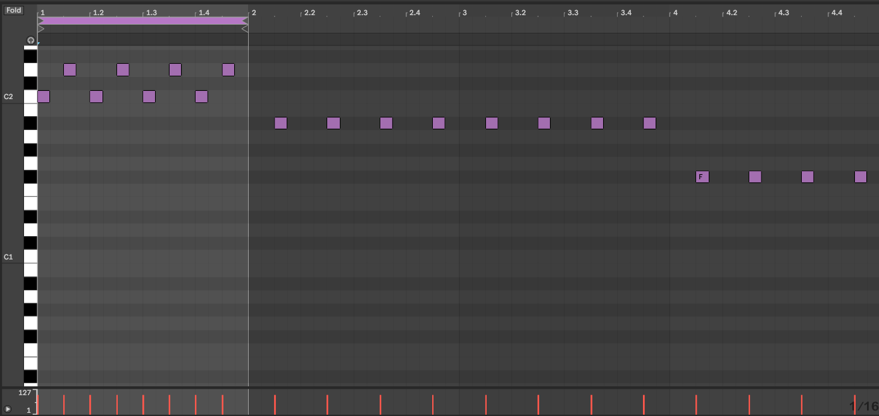

Section 5’s melody is just one note: C3.

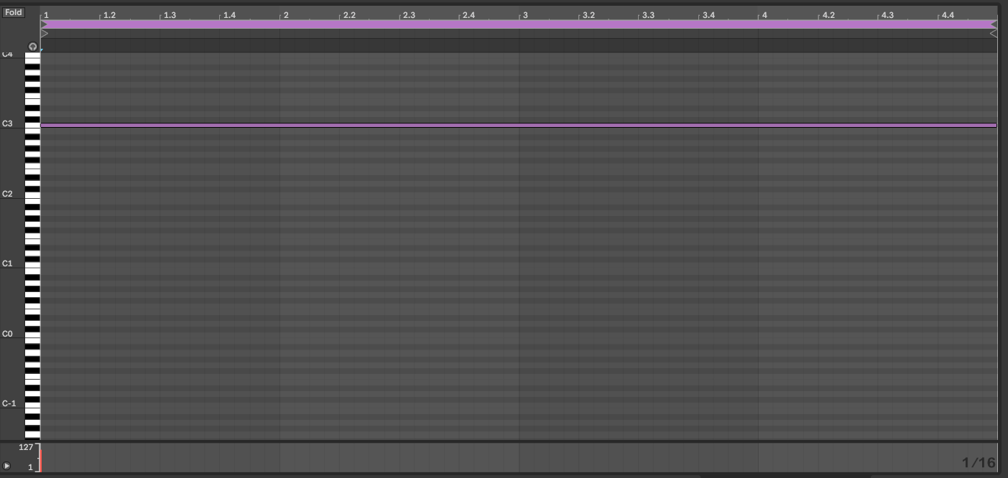

1. Channel 4 — bass

Do the Ctrl + Shift + C shortcut on your keyboard again to create another MIDI channel. Then, find the ‘Bass Long 01 A.wav’ file in the Essential Clubsounds sample library. Rather than dragging & dropping it to the actual channel, make sure the channel is highlighted, then drag & drop it into the bottom right where it says **’5-MIDI’** until the bottom section changes, and where it says **‘Drop a Sample or Instrument Here,’** drop it there (you can do this with any audio file, it’s basically how to use the MIDI channel as a sampler; though you shouldn’t do that because there’s a much different better way of doing it with an instrument called **‘Sampler,’** but this track uses the MIDI channel’s built in sampler since it only needs simple melodies).

Now that you’ve got the bass in there, we can get the patterns. These patterns may take a while for you to get right, since they’re quite complicated.

Section 1’s pattern is actually very simple, however, since it’s only one note — F2. This is the ‘offbeat bass’ pattern.

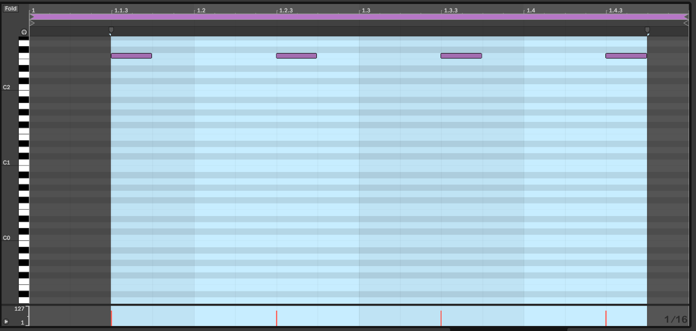

Section 2’s pattern is where it begins to get complicated. Still 4 beats long, it now has two notes playing after each other — G#2 and then F2.

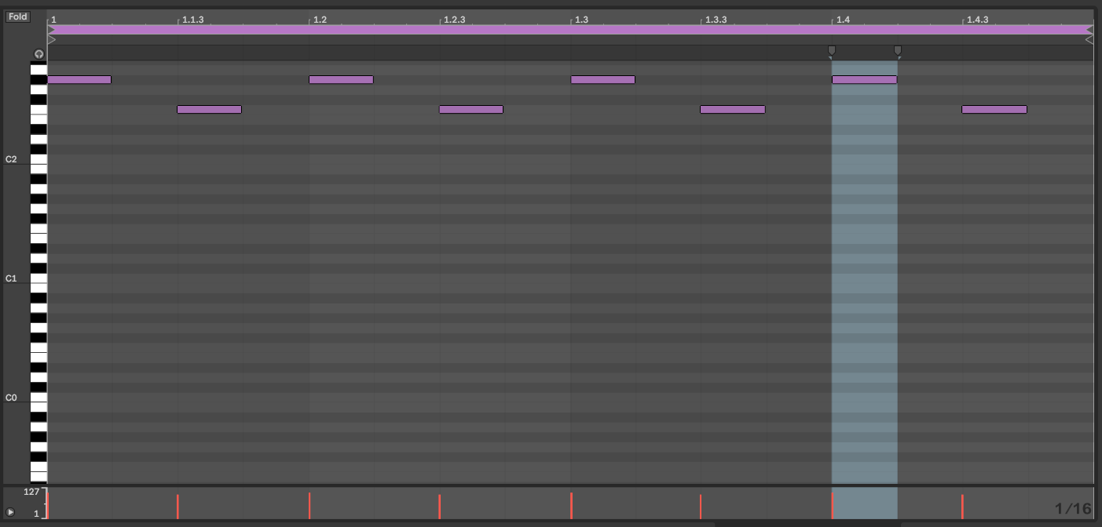

Section 3’s pattern is the actual complicated one — it has various notes. They are listed below:

G#2, F2, G#2. F2, G#2, F2, G#2, F2, F#2, F2, F#2, F2, F#2, F2, F#2, F2, G2, F2, G2, F2, G2, F2, G2, F2. The melody is 16 beats long (you should know how to extend and cut a section clip by now!).

Your finished pattern should look like this:

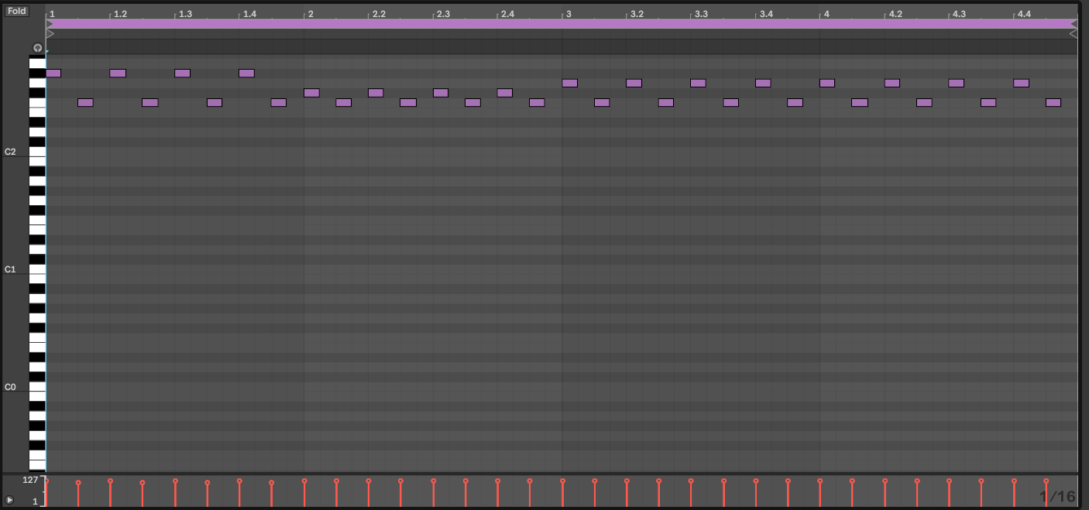

Section 4’s pattern is fairly simple. It is the Pleasure Mix bass. It consists of four notes: C3, B2, A2 and good ol’ F2. This pattern is also 16 beats long. It looks like this:

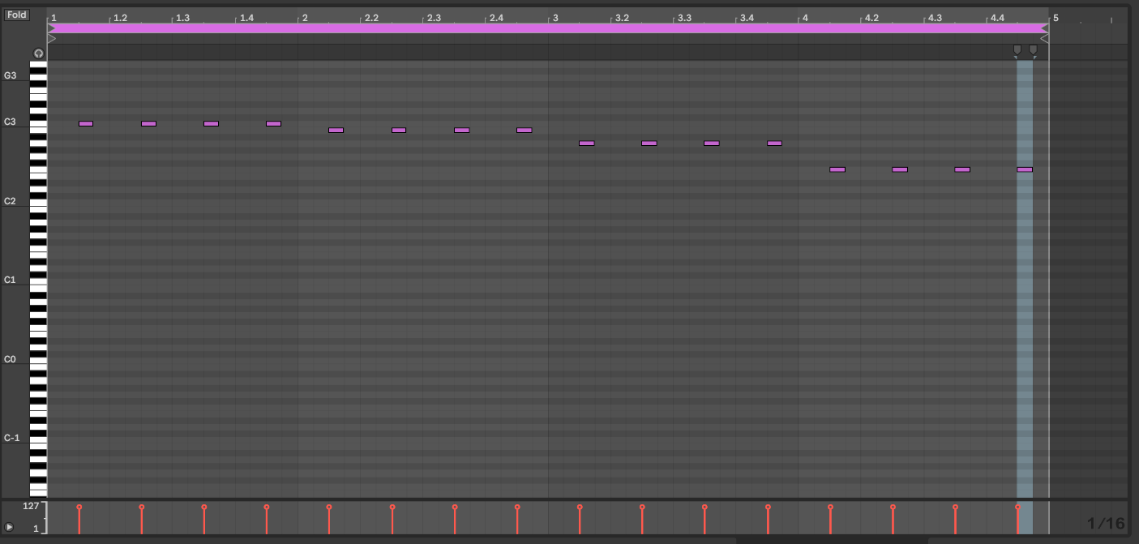

1. 1 Effects

The only effect that is only really used is in the **Audio Effects** section — under **Audio Effect Rack** and **Performance & DJ.** The effect is called DJ tools, and I’ve applied it to the group which is channels 1 & 2.

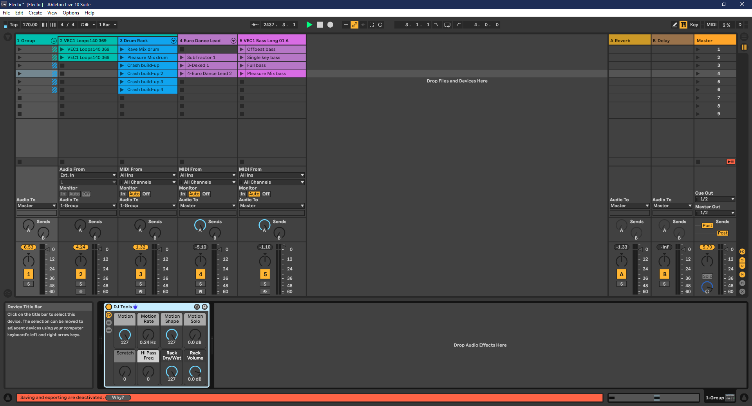

What I sometimes do with DJ Tools in the Rave Mix of Spry is I turn it on and off during the track. This adds a really nice touch to the finished track.

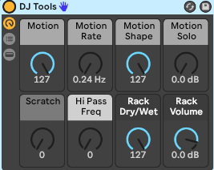

You need to make sure that the settings match these ***EXACTLY*** to perfectly re-create the effect that I used.



Keep in mind that during the track I also turn **Motion Solo** up and down. The Rave Mix actually starts with **Motion Solo** on –INF dB.

7.2 Mastering

This is the final section of the tutorial. It’s very short too because it’s only one simple thing. In nearly ALL of my tracks, I add an effect to the Master called **Stereo Enhanced Master.** This makes the Master sound much better and professional. This effect can be found in the **Mixing & Mastering** folder in the **Audio Effects** section of Ableton.

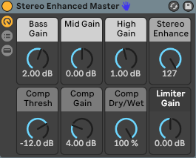

The only thing I do is I bring **Stereo Enhance** up to 127.